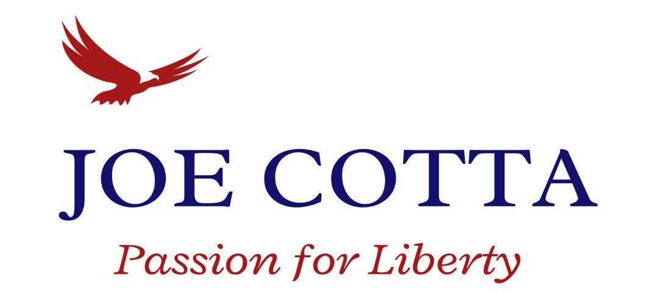

October 5, 2022
This is a sensitive topic because of my involvement, but deserves as much attention as any other topic.
How would you describe an ideally financed campaign? How much money would you like to see come from private citizens, organizations, PACs (political action committees) and Super PACs? What percentage of donations would you like to see come from the area being represented, like district 8?
Citizens and organizations can donate a maximum of $1000 per election (primary and general). PACs can make donations of no more than $5000 per election. Super PACs can spend unlimited amounts of money to influence elections but cannot donate directly to candidates.
In District 8 and surrounding districts (9,15,16), winning candidates from the 2020 elections raised between $28K – $99K (avg around $40-50K), with no Super PAC contributions to any candidates in past years. I am on pace to be in this range. There are plenty of occasions where strong fundraising does not lead to victory.
Other candidates set out to raise as much money as possible in hopes that widespread name recognition will lead to a victory. My opponent seems to have chosen this strategy. She has invested in campaign management, marketing, and consultants and leveraged those services to aggressively raise funds and market the campaign.
My opponent has received $165,000 from one Super PAC in Olympia (WA Realtors PAC - RPAC). If you go to their website, you can see that a very small percentage (2%) of contributions come from the Tri-cities.
RPAC Major Investors | Washington Realtors (warealtor.org)
So far, the RPAC has raised approximately $569K to influence elections. Surprisingly, approximately 50% of these funds are coming to our own district 8 to influence the elections of our own state representatives.
That is a lot of westside money coming to the eastside to influence our elections.
April has raised $125K of her own, but again is largely supported by those in housing and land development industries.
One of the more surprising elements to this dynamic is that I am not against realtors, construction, or the housing market. I understand that burdensome permitting processes, overregulation, utility restrictions (natural gas ban), closing our forests (lumber would lower supply costs & create WA state jobs), an outdated Growth Management Act, and taxes are making homes unaffordable. Olympia’s focus on high-density living is ruining the American dream of home ownership. I am also familiar with the environmental agenda of Futurewise, the Hirst decision, and other environmental obstacles. My point is, I am not the enemy of the real estate industry, so what is the SuperPAC trying to buy?
Is it financially unresponsible to spend so much money and people’s contributions on name recognition and branding, with such limited policy content? I paid no consultants or marketing firms. I was outspent over 11:1 in the primary and still qualified for the general election finishing only 1% of the votes behind the leader.
I am supported by many who have heard my resonating message of fighting tyranny and corruption. Many of these voters don’t have much money to give, but they are willing to work. They tirelessly go door to door explaining my platform and distinctions, forward emails, and gather friends.
I feel a tremendous sense of responsibility when the kind lady checking me out at the grocery store donates $100 to my campaign in this kind of economy. I take it very seriously.
Would someone who utilizes $290K for a campaign that typically sees $40-50K be fiscally conservative with your tax dollars in Olympia? Whose interests will be served?
Please share this email with your family and friends and visit our website to volunteer.

Thank you!
Joe Cotta
Passion For Liberty
VoteJoeCotta.com

