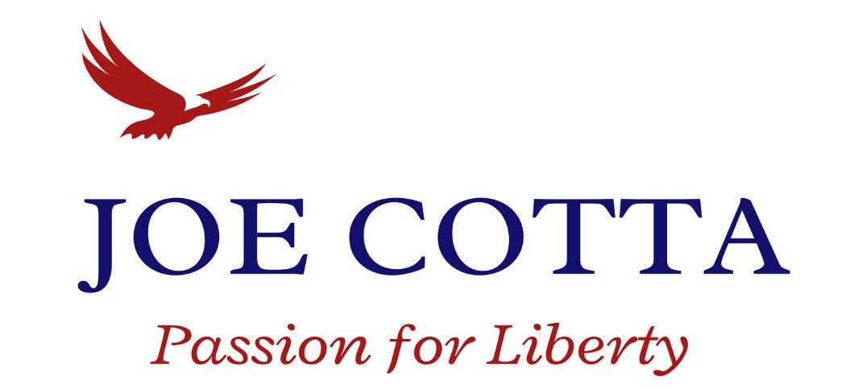

October 19, 2022
Washington State Agriculture produces $10.6 Billion in revenue from 39,500 farms and ranches, 89% of them being small farms. Agriculture is 12 percent of Washington State’s overall economy and our 2nd largest export. Agriculture's Contribution Washington State Economy (wsfb.com)
The last couple of years have been legislatively brutal to agriculture with low carbon fuel standard mandates, a governor-appointed environmental justice council, and a new team from the Division of Occupational Safety and Health (DOSH) called the Agriculture Compliance Unit. These regulatory changes were added, despite our state’s leadership in agricultural safety.
In past times, Agriculture inspectors sought education before enforcement. Routine and even surprise audits were somewhat expected, but the compliance official was typically helpful in pointing out practices that needed to be corrected. They simply wanted to make sure the laws were followed. In the Agriculture community, we have sought to partner with government compliance inspectors, because farmers want their farms to be safe. When it comes to employee safety and worker fatalities, we are as much as 2-3 times safer than other states.
However, the attack on capitalism through regulation and agency law has now firmly planted itself in our Washington small farms.
Agriculture overtime exemptions allow farms to make hay while the sun shines. A flat wage keeps the food supply cost lower and extended hours during peak demand allow for rest and time with families in the winter.
However, overtime wages phasing in over the next couple of years will put small farms out of business and raise food costs, at a time where the cost of food is about to radically increase, even without these changes. Ag worker wages have increased 5% per year for the last 10 years, with the average wage now over $18/hour. Some farms provide discounted housing, transportation, gas, etc.
New Air quality index thresholds for mask requirements are lower than the EPA thresholds. Artificial shade (free shade doesn’t count) must now be provided for ag workers at 89 degrees.
Keeping our workforce safe is always a top priority, but at some point, productivity must be considered. All the regulations and agency law changes limit production and efficiency, which leaves Washington farms unable to compete in a global economy.
All farmers want is an even playing field, but state regulations have put Washington growers at an unfair disadvantage. Farmers are selling to developers or larger companies to retire because agriculture is discouraged.
Can Agriculture absorb the costs? Farmers don’t set their prices. Productivity is down, wages are up, and regulation is tightening the noose.
When farming costs and agency regulation increases, the smallest farms are the first to go out of business, until the large companies remain, monopolizing the food supply. If you don’t like the big tech oligarchy restricting free speech and controlling the information you receive, what do you think will happen if big tech giants control the food supply? This is where Washington state policy is pointed.
There are many potential solutions. Naturally, repealing all the above would be a good place to start. However, small steps would include an agriculture overtime exemption window. If we can’t repeal overtime, we can at least provide a window during harvest to make it affordable to farms and give ag employees more hours.
Make regulatory changes require approval by the legislature. This would end much of the unreasonable and unaccountable regulation.
I have worked and served in agriculture my whole life. I will defend agriculture, our dams, and the food on your table from tyrannical regulation.
Please share this email, donate, volunteer, and encourage your friends
to vote. Our farming future depends on your involvement. We must bring liberty back to Washington State.
Joe Cotta
voteJoeCotta.com

